1. BlueZone Web to Host Software. This software allows users to telnet from their browser to AS400 (TN5250), mainframe (TN3270), Linux, AIX, OpenVMS (Telnet).

The software is running on DLSMSPBLZ1 and DLSMSPBLZ2 servers accessed through the URL hosts na.avonet.net. The URL is runs on the Dallas Load balancer.

C:\Users\lynchj>nslookup hosts.na.avonet.net

Server: anydns1.global.avon.com

Address: 134.65.0.1

Non-authoritative answer:

Name: generic-ns.dlsnlbpint.avon.net

Address: 134.65.226.11

Aliases: hosts.na.avonet.net

The home page of the URL looks like

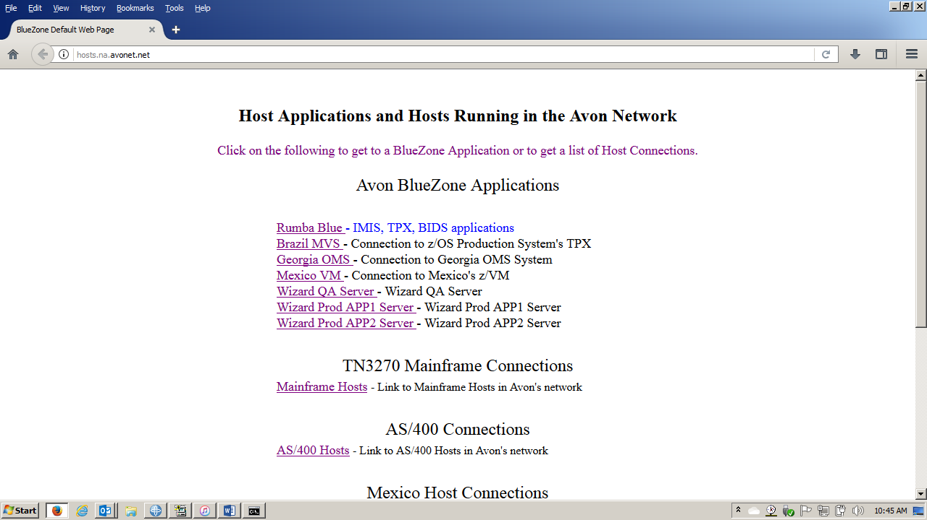

Included in this software is the ability to have a full screen FTP gooey interface.

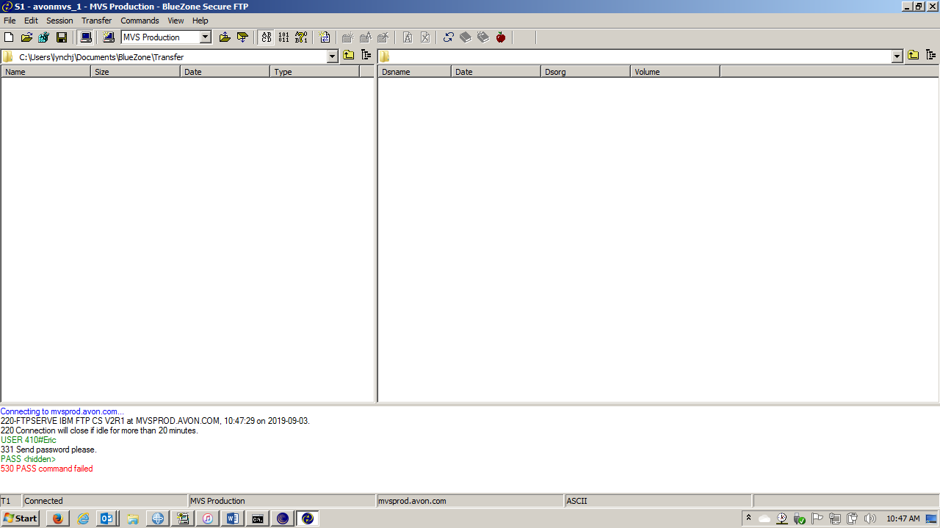

BlueZone works by downloading java applets. The telnet sessions are managed through HTML code on the server. You can override the configuration of the applet that was downloaded the first time the user did a telnet. FTP interfaces are loaded the first time you do a telnet and are not configurable through HTML code.

Once the user uses the server to get a telnet session, it is between the user’s work station and the host that was the target of the Telnet. It does not run through the server. It does keep a heartbeat on port 8421 to the BlueZone License Manager to keep the number of concurrent users count.

1. BlueZone License Manager runs on DLSMSPBLZ1 server. It is configured to run 1200 concurrent users. It is bound by IP address of the License Manager. One user (IP address) can have multiple sessions per license. There is a heartbeat kept between the telnet session and the license manager on port 8421. You cannot start a telnet session without establishing this heartbeat.

All the configured sessions on the DLSMSPBLZ1/2 servers are configured to use this license manager.

There are versions of the BlueZone Desktop running. Mostly in the Citrix environment. These sessions connect to the License manager to take advantage of our existing licensing contract.

There are two current problems happening:

1. The full screen FTP sessions have been downloaded prior to the Dallas move and still point to the Rye server for licensing.

There are two ways to fix this:

1. Delete the MyDocuments/BlueZone/Config/ \*.zft file and restart the browser and download a new applet from the server that points to the right License Manager

Or

On the FTP session

Go to Session

Go to Configure

Go to License Manager

Add dlsmspblz1.na.avonet.net

Remove ryemspblz1.na.avonet

Back out

Go to File and Save the change

1. In DNS:

Delete the ANAME ryemspblz1.na.avonet.net

Create a CNAME ryemapblz1.na.avonet.net pointing to dlsmspblz1.na.avonet

1. The BlueZone Desktop software needs to be configured to point to the Dallas License Manager.

There are two ways to fix this:

1. On the Desktop Startup

Go to Session

Go to Configure

Go to License Manager

Add dlsmspblz1.na.avonet.net

Remove ryemspblz1.na.avonet

Back out

Go to File and Save the change

1. In DNS:

Delete the ANAME ryemspblz1.na.avonet.net

Create a CNAME ryemapblz1.na.avonet.net pointing to dlsmspblz1.na.avonet

1. BlueZone Desktop Software has been installed. It runs mainly in the Citrix environment. It needs to be reconfigured to point to the Dallas BlueZone License Manager. Where it is installed and running, I don’t know. It was installed taking advantage of the Licensing agreement running on the BlueZone License manager.